INTRODUCTION: AETHER INTELLIGENCE
An Intelligent Emergency Response Infrastructure

Core idea
Aether Intelligence is an intelligent emergency-response platform that creates a real-time digital representation of an emergency environment, allowing healthcare authorities and emergency teams to see incidents, patients, ambulances, hospitals, traffic conditions and available resources in one operational system.
The system combines:
- 3D Digital Twin
- Artificial Intelligence & Smart IoT Wearables
- Medical Drones & Emergency routing
key message - We are building an intelligent operational layer that connects people, emergency resources and physical infrastructure into one live system.

PROBLEM STATEMENT — THE EMERGENCY RESPONSE GAP IN RURALS
Our problem statement is: Emergency response is fragmented, reactive and information-constrained.
In Limpopo, an emergency can become life-threatening not because help does not exist, but because the right help may not know where it is, where it is needed, or how to reach the person in time.
Consider a person living alone in a deep-rural community. It could be an elderly person, a 30-year-old experiencing a seizure, a farmer injured while herding cattle, or anyone who suddenly becomes unconscious or seriously injured while no one else is nearby. In many rural communities, people still travel long-distance to only collect medical pills, which is still costly. When an emergency occurs, the nearest ambulance, clinic, police vehicle, or responder may be many kilometres away.
The problem becomes even more severe in Limpopo's mountainous and geographically dispersed communities, where network coverage remains unreliable. A person may need emergency assistance but be unable to make a call, send their location, or communicate with responders. Even when an emergency is reported, responders may struggle to determine the patient's exact location and the most efficient resource to deploy.
This is not only a problem of insufficient resources. It is also a problem of resource visibility, coordination and utilisation.
Healthcare and emergency services can have personnel, ambulances, clinics and other resources distributed across a large geographic area, yet decision-makers may not have a continuously updated picture of where those resources are, whether they are available, where they are currently travelling, and where demand is emerging.
For example, an ambulance dispatched from Polokwane to Tzaneen may still be travelling or returning when a new emergency is reported in Mankweng. Without real-time visibility of the ambulance's location and status, another ambulance may be dispatched from a hospital farther away—even though the ambulance already on the road could potentially have responded much sooner.
The result is a fragmented emergency-response environment in which valuable resources exist, but are not always coordinated according to real-time need.
For a province as geographically complex as Limpopo, this creates a critical question:
What if emergency services could see the province as a live, continuously changing system—knowing where people need help, where ambulances and responders are, which facilities have capacity, and which available resource can reach an incident fastest?
The challenge is therefore not simply to acquire more emergency resources.
The challenge is to make the resources that already exist more visible, intelligent, coordinated and responsive—particularly for people living alone and communities where distance, terrain and network limitations can turn minutes into life-or-death consequences.
Emergency medical response teams need a unified, real-time view of incidents, patients, available resources, geographic conditions and response routes so that critical decisions can be made faster and resources can be allocated more intelligently.

THE SOLUTION
A REAL-TIME EMERGENCY INTELLIGENCE PLATFORM
Our solution involves a real-time emergency intelligence infrastructure designed to help with intelligent, coordinated response.
Instead of relying primarily on fragmented information, phone calls and estimates, we create a live digital twin of the environment—giving decision-makers a continuously updated view of incidents, patients, ambulances, healthcare facilities and other response resources.
The platform connects people, resources and intelligent decision-making through one system.

1. THE DIGITAL TWIN
At the centre is a real-time 3D digital twin. It provides a visual representation of the environment and continuously maps relevant emergency information, including:
- Roads and road conditions
- Hospitals, clinics and emergency facilities
- Patient locations
- Available emergency resources
This allows coordinators to move beyond asking: "Where is the nearest ambulance?" and instead ask: "Which available resource can respond to this incident most effectively, based on its current location, status, route and the severity of the emergency?"
The system can therefore support real-time resource allocation and coordination rather than simply displaying information.

2. THE SMART EMERGENCY WEARABLE
The second component connects the individual directly to the emergency-response system.
For the prototype, the wearable provides: Emergency activation → GPS location → vital-sign telemetry → dashboard
When the user presses the emergency button, the system transmits the available patient information and location to the platform.
The command centre can then see:
- Who requires assistance
- Where the person is located
- Which emergency resources are available nearby
This becomes particularly important for people living alone, people in remote communities, and individuals who may be unable to communicate their location during an emergency.
Because emergency technology must work for more than one type of user, the device can provide multiple forms of feedback:
- Sound for users who can hear
- Vibration for users who may not hear an alert
- Visual indicators where appropriate
If the emergency button is accidentally activated, the wearable can provide an immediate cancellation mechanism, allowing the user to deactivate a false alarm before unnecessary resources are dispatched.

3. MEDICAL DRONE
In areas where distance, terrain or road accessibility makes conventional response difficult, the platform can coordinate remotely operated aerial and ground assets.
The drone provides rapid aerial access and can be used for:
- Emergency assessment
- Delivery of lightweight medical supplies
- Communication support where appropriate
- Reaching difficult terrain

It can analyse information from multiple sources and help determine:
- Which ambulance is available
- Where each ambulance currently is
- Which facility has available capacity
- Which resource is closest to an incident
- Which route is most appropriate
- Whether another emergency resource is already operating nearby
- Where demand is increasing
- Where resources may be under-utilised or overstretched
For example, if an ambulance travelling between two place is already close to a newly reported incident, it can identify that existing resource and present it to the dispatcher as a potential response option—rather than treating every emergency as an isolated event.
The human dispatcher remains in control. It provides the real-time intelligence required to make a faster and better-informed decision.
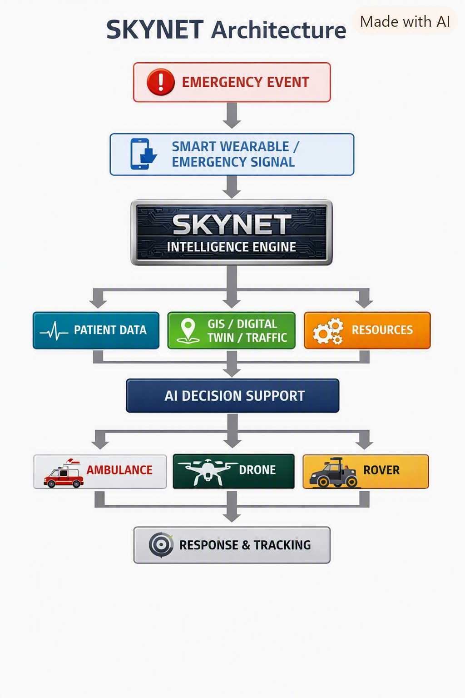

MARKETABILITY & BUILDABILITY
MARKETABILITY
The System is not designed primarily as a consumer product. Its strongest market lies within the institutional emergency-response, healthcare and public-safety ecosystem, where organisations already manage large numbers of people, vehicles, facilities and geographically distributed resources.
The value proposition is straightforward: Give institutions real-time visibility of their resources and the intelligence required to coordinate those resources more effectively.
Primary Customers
Our initial target customers are:
- Provincial Departments of Health
- Hospitals and Healthcare Networks
- Emergency Medical Services (EMS)
- Municipalities
- Disaster Management Agencies

Future Markets
The same platform architecture can be adapted to other sectors where real-time spatial intelligence and resource coordination are critical:
- Police and Public Safety
- Mining and Industrial Operations
- Rural Healthcare Networks
- Private Emergency-Response Companies
- Large-Scale Disaster and Humanitarian Response
The underlying technology is therefore not limited to one ambulance-dispatch use case.
REVENUE MODEL
Potential Revenue Streams
1. Platform Licensing: Institutions license access to the system emergency intelligence platform.
2. SaaS Subscriptions: Annual subscriptions based on the number of facilities, users, vehicles or operational regions.
3. Emergency Operations Contracts: Long-term contracts for deployment, maintenance, monitoring and operational support.
4. Hardware Deployment: Revenue from the deployment of smart wearables, tracking devices, IoT sensors and other connected emergency equipment.
5. AI & Data Analytics: Advanced analytics for resource utilisation, demand forecasting, response-time analysis and operational planning.

BUILDABILITY
The most important principle behind our entry is: We are not claiming that we will deploy an autonomous emergency-response system across the entire Limpopo Province overnight.
Instead, we are building a controlled, demonstrable prototype that proves the underlying architecture.
PROTOTYPE
For the prototype, we focus on a representative geographic corridor: Polokwane → Mankweng → Seshego. Within this controlled environment, the system will simulate the conditions required to demonstrate the platform's core intelligence.
The prototype environment includes:
- Synthetic 3D terrain and geographic environment
- Road networks and intersections
- Hospitals and emergency facilities
- Ambulances and other response resources
- Simulated traffic conditions
- Patient locations
- Smart wearable telemetry
- Drone assets
- Real-time digital-twin visualisation
The demonstration will show how information moves through the system.
The individual technologies required for the prototype already exist. The innovation lies in integrating them into one operational intelligence architecture.

TOTAL COST FOR PROTOTYPE IMPLEMENTATION
Category | Prototype Allocation
Emergency Wearable / IoT System | R3,000
GPS, Telemetry & Networking | R3,500
Drone Platform & Medical Payload | R7,000
Rover / Ground Robotics | R5,000
Sensors, Electronics & Control | R3,500
Fabrication & Mechanical Components | R3,500
Software / Cloud / Connectivity | R2,000
Testing & Demonstration Infrastructure | R2,500
Contingency | R2,500
TOTAL PROTOTYPE COST | R45,000

The prototype demonstrates:
Emergency Watch → detects/triggers critical event
Network Layer → transmits the emergency signal
Digital Twin → identifies incident location
Resource Allocation Engine → compares Area A incident against available Area B ambulance
Dispatch System → selects the fastest suitable resource
Autonomous Response → drone launches from nearest hub
Rover → performs last-mile ground access
Hospital Selection → identifies appropriate receiving facility
Command Centre → visualizes the entire operation.
A real-time provincial emergency intelligence system that connects the patient, the environment, the emergency vehicle and robotic response assets through a digital twin and AI decision engine.

TEAM MEMBERS

Letsie Tumisho Renee | Robotics & Software Engineer

 | 
 | Judge Tshwarelo Senoamadi | AI & Software Engineer

 |  | 
 | Drone & IoT Engineer | Nakana Sarah Surprise

